*PERSONAL PROFILE*

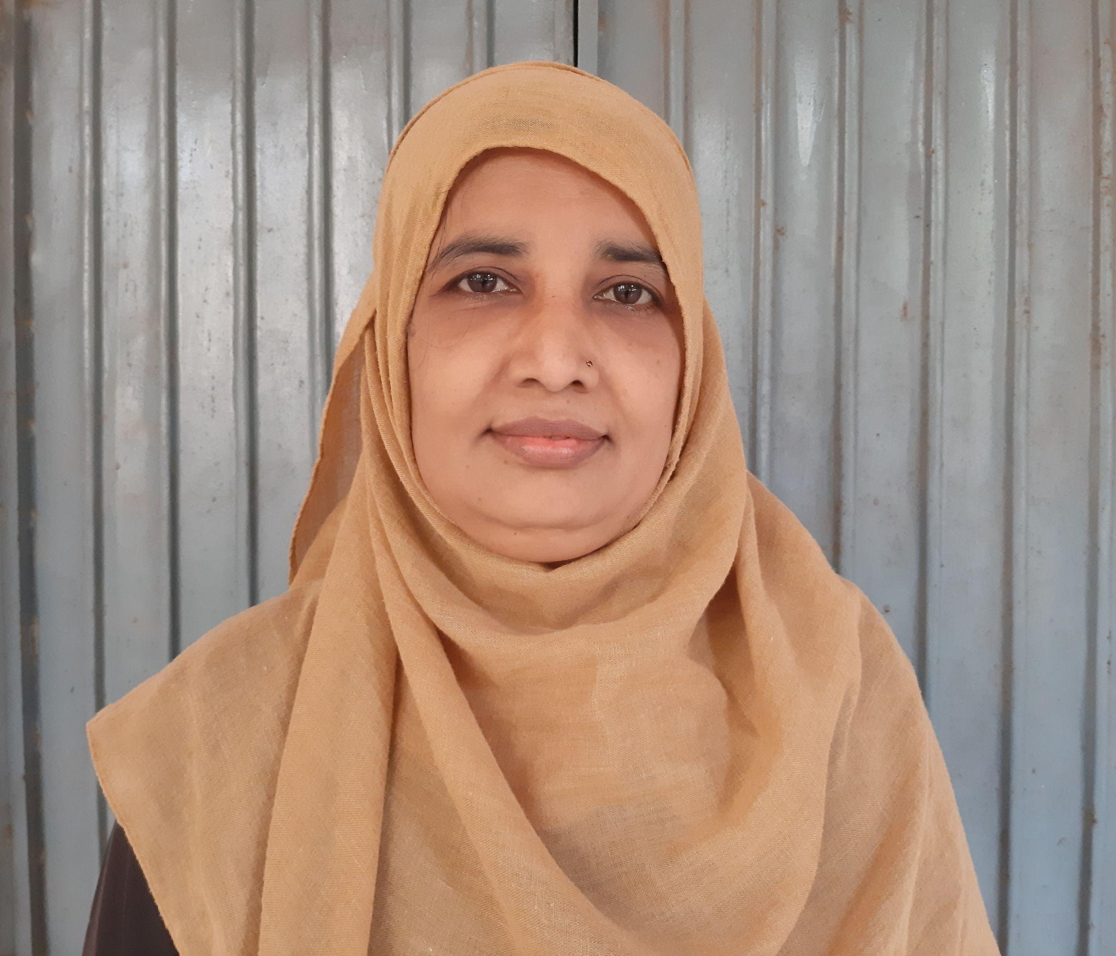

**Name:** Rasiqa Fathima

**Designation:** Lecturer in History

**Qualification**: M.A, B.Ed.

**Experience:** 2 years

**Hobbies:** Story writings for AIR Vijayawada & reading books

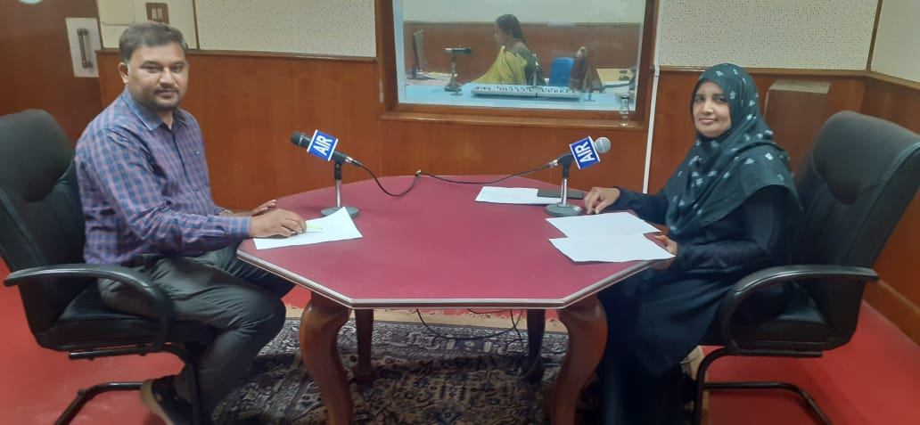

**CellNo**: 9848675911

**Mail Id**: rasiqafathima7@gmail.com

EDUCATIONAL QUALIFICATION

|  |  |  |  |  |
| --- | --- | --- | --- | --- |
| **S.NO** | **COURSE** | **BOARD/**  **UNIVERSITY** | **YEAR OF**  **PASSING** | **PERCENTAGE** |
| 1 | S.S.C. | BOARDOF  SECONDARY  EDUCATION | 1993 | 55% |
| 2. | INTERMEDIATE | BOARDOF  INTERMEDIATE  EDUCATION | 1995 | 53.5% |
| 3 | B.A  (Public administration, sociology, Urdu literature) | DR.B.R AMBEDKAR OPEN UNIVERSITY | 2000 | 55% |
| 4 | B.Ed. | ACHARYA NAGARJUNA UNIVERSITY | 2007 | 65% |
| 5 | MA (History) | MAULANA AZAD NATIONAL URDU UNIVERSITY | 2009 | First class |
| 6 | MA(URDU) | MAULANA AZAD NATIONAL URDU UNIVERSITY | 2010 | First class |

**Professional Experience:**

1. Worked as a Guest Teacher in Urdu and history at A.P Residential girls minority school,

Vijayawada. (2003-2020)

2. Joined as a guest Lecturer in History in SRR & CVR Government Degree College.

**Workshops attended:**

***International/National:***

* **Research methodologies of contemporary times: English language, Literature and Teaching** organized by department of English on 5th February 2022.
* **Health-Lifestyle Management** a one day National Webinar organized by the physical education, SRR & CVR government degree college on 17th Feb 2022.
* **National intellectual property awareness mission** organized by intellectual property office, INDIA on 28 February, 2022.
* **Importance of Intellectual property rights in higher education institutions** organized by Department of commerce on 6th may 2022.
* **Women Entrepreneurship opportunities and challenges** organized by department of economics on 26th august 2022.
* **Sports nutrition diet and reforming Eating Habits** organized by physical education SRR & CVR GDC (A), with QUA nutrition on 27th august 2022.